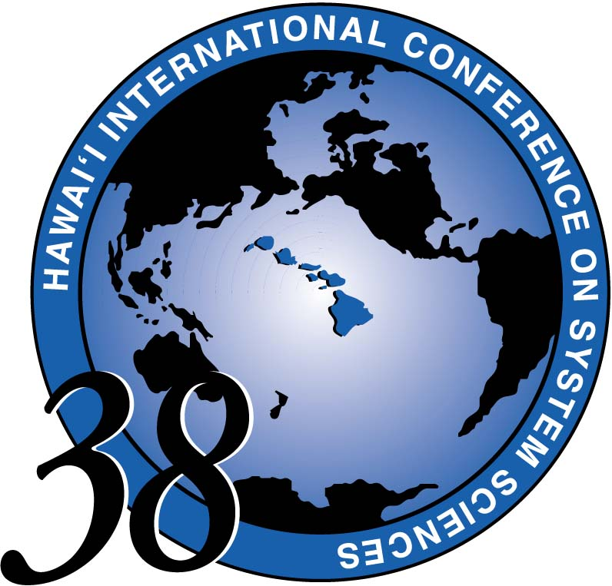
HICSS-38 CONFERENCE REGISTRATION

JANUARY 3-6, 2005
Hilton Waikoloa Village
on the Big Island of Hawaii

How many years have you attended HICSS (including this year for HICSS-38)?

(Please type or print clearly)

LAST/FAMILY NAME:
Your First/Given Name:
Which are you?
□ Author: PID Code of paper(s):
If code is unknown, which Track or Minitrack is your paper in?

□ Minitrack Chair:
Track Code (Circle one): CL CS DD DT ET HC IN OS ST

□ Tutorial Presenter - Name of Tutorial:

- General participant
FIRST NAME

Last Name

Corporate or
Academic Affiliation

State or Country

PLEASE PRINT
CLEARLY. THIS
IS FOR YOUR
NAMETAG

Employer: Department:

Street / P.O. Box:

City and / or Province:

State and Country & Zip Code:
□ Is this your home address? □ Professional address?
Page 1 of 2
HICSS-38 CONFERENCE REGISTRATION FORM Page 2 of 2
YOUR NAME:
Telephone: / Fax: /

E-Mail Address:

(optional) Website:

******************************************* PAYMENT INFORMATION ************************************************
* Postmarked Date
EARLY REGISTRATION Friday 4pm Hawaii time October 1 * $525
REGULAR REGISTRATION Saturday Oct 2 - Friday Dec 10 * $575
LATE/On-Site REGISTRATION Saturday Dec 11 - Thursday Jan 6 * $675
□ Visa or □ Mastercard These are the only credit cards accepted.

Card Number Exp Date: /
month year

Name as it appears on credit card account:

Signature of Cardholder:
Cancellation policy: Until DEC. 10 There is a $100 administrative fee. No refunds after Dec. 10.
All cancellation notices must be in writing to hicss@hawaii.edu
***************************************************************************************************************************************
TUTORIAL DAY MONDAY, JANUARY 3, 2005
TUTORIALS ARE INCLUDED IN YOUR REGISTRATION FEE.
See your Advance Program Announcement and the HICSS web site for tutorial abstracts and bio information about speakers.
Please mark your choice: choose one Full Day, or one Morning and/or one Afternoon session.
Full Day (9am – 4pm)
□ Fundamentals – and Beyond – of Network Security OR □ Literacy in the Internet Age
□ Strategic & Economic Methods for Assessment of IV & V Activities

Morning (9am - 12 noon)
□ Advances in Technology-Supported Learning
□ Successful Science from the Logical Positivist Perspective
□ Persistent Conversation
□ Wireless Sensor Networks
□ Enterprise Metadata
□ Business Modeling and Requirements Using UML
Afternoon (1pm - 4pm)
□ Collaboration Engineering
□ Semantic Web
□ Problem-based Learning Systems and Technologies
□ Intelligent Ubiquitous Information System
□ IT Responses to Changing Corporate Governance
□ Multidisciplinary System Design Knowledge

For more information call: Sandra Laney, Conference Administrator, 808-956-3251 or email hicss@hawaii.edu
Make checks payable to HICSS / RCUH 002147 and mail to:
HICSS CONFERENCE OFFICE
2404 Maile Way A202 Honolulu, Hawaii 96822
PLEASE FAX BOTH PAGES TO 808-956-5759 OR EMAIL TO hicss@hawaii.edu
You must make your hotel reservations directly with the hotel as soon as possible. For a hotel reservation form visit
our web site http://www.hicss.hawaii.edu or go to http://www.hiltonwaikoloavillage.com

