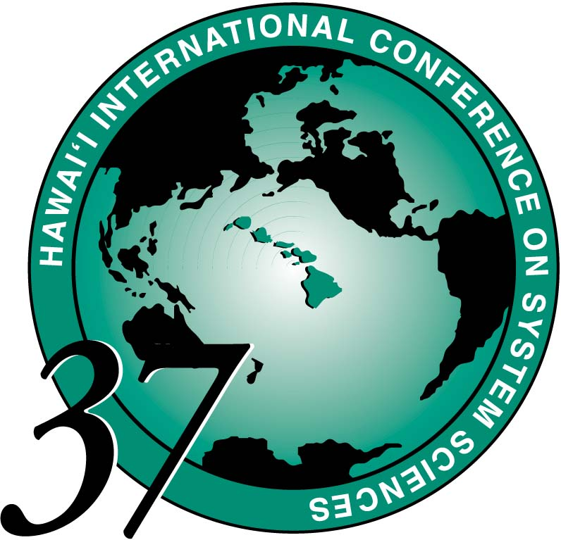

HICSS-37
BEST PAPER
AWARDS

Track: COLLABORATION SYSTEMS AND TECHNOLOGY

Minitrack: Negotiation Support Systems
Paper: Decision and Visualization for Negotiation
Author(s): Jean-Sebestien Monzani, Samuel Bendahan, and Yves Pigneur
Track: COMPLEX SYSTEMS

Minitrack: Computational Models for Benchmarking and Ancillary Services
Paper: Coordinated Interchange Scheduling and Opportunities Cost Payment: A Market
Proposal to Seams Issues
Authors: Jie Chen, James S. Thorp, and Timothy D. Mount
Track: DECISION TECHNOLOGIES FOR MANAGEMENT

Minitrack: E-Services
Paper: Alert-driven E-Services Management
Authors: Dickson K.W. Chiu, Benny W.C. Kwok, Ray L.S. Wong, S.C. Cheung, and Eleanna Kafeza
Track: DIGITAL DOCUMENTS AND MEDIA

Minitrack: Persistent Conversation
Paper: "Newsgroup Crowds and AuthorLines: Visualizing the Activity of Individuals in
Conversational Cyberspaces"
Authors: Fernanda B. Viegas and Marc Smith
Track: EMERGING TECHNOLOGIES
Minitrack: Symbiotic Interactions Between Users and Intelligent Systems
Paper: Symbiotic Value of an Embodied Agent in Language Learning
Author: Dominic Massaro
Track: INFORMATION TECHNOLOGY IN HEALTH CARE
Minitrack: Information Systems Supporting Quality Patient Care, Patient
Safety and Patient-Centric Technologies
Paper: Telemedicine Encounter Quality: Comparing Patient and Provider Perspectives
of a Social-Technical System
Authors: Cynthia LeRouge, Alan R. Hevner, Rosann Collins, Monica Garfield, and David Law
Track: INTERNET AND THE DIGITAL ECONOMY

Minitrack: Electronic Marketing
Paper: Does One Standard Promote Faster Growth? An Econometric Analysis of the
International Diffusion of Wireless Technology
Authors: Robert J. Kauffman and Angsana A. Techatassanasoontorn

Track: ORGANIZATIONAL SYSTEMS AND TECHNOLOGY

Minitrack: Outsourcing of Information Systems
Paper: An Empirical Assessment of Transactional Risks of IT Outsourcing
Arrangements: An Event Study
Authors: Wonseok Oh and Michale J. Gallivan
Track: SOFTWARE TECHNOLOGY
Minitrack: Adaptive and Evolvable Software Systems: Techniques,
Tools and Applications
Paper: A Generative Programming Framework for Adaptive Middleware
Authors: Venkita Subramonian and Christopher Gill

