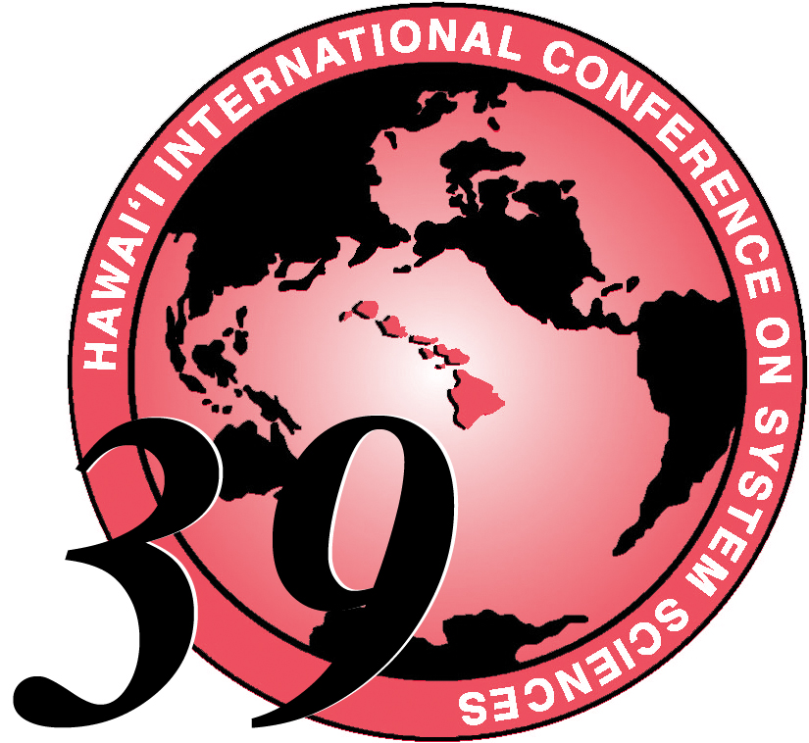
HICSS-39 CONFERENCE REGISTRATION

JANUARY 4-7, 2006
Hyatt Regency Kauai Resort and Spa
1571 Poipu Road Koloa, Hawaii 96756 Tel: 808-742-1234

Is this your first HICSS Conference? □ Yes □ No
The following is essential information. Please make sure your mailing address is complete.
LAST/FAMILY NAME:

Your First/Given Name:
Employer: Department:

Street / P.O. Box:

City and / or Province:

State and Country & Zip Code

Which are you?
□ Author: Which Minitrack?
□ Minitrack Chair: Which Track?

□ Tutorial/Workshop/Symposium Presenter
Name of Session:
- General participant

FIRST NAME

Last Name
Preferred Corporate
or Academic Affiliation
U.S State or Country

PLEASE PRINT
CLEARLY.
THIS IS FOR
YOUR
NAMETAG

HICSS-39 Page 1 of 2
Page 2 of 2 HICSS-39 CONFERENCE REGISTRATION FORM
YOUR NAME: (

Telephone: / Fax: /

E-Mail Address:

********************************************* PAYMENT INFORMATION ************************************************
Note: For wire transfers you must call the HICSS Office (808) 956-3251 for specific instructions.
* Postmarked Dates
EARLY REGISTRATION until Thursday Sept 15 * $525 □
REGULAR REGISTRATION Friday Sept 16 - Saturday Dec 15 * $575 □
LATE/On-Site REGISTRATION Friday Dec 16 - Friday Jan 6 * $675 □
□ Visa or □ MasterCard These are the only credit cards accepted.

Card Number Exp Date: /

month year
Name as it appears on credit card account:

Signature of Cardholder:
HICSS Cancellation Policy: Your registration fee will be refunded in full until October 15. After Oct 15 we will deduct a $150 administrative fee until Dec 15. There are no refunds after Dec 15, 2005. All cancellation requests must be in writing to hicss@hawaii.edu
***************************************************************************************************************************************
THESE SESSIONS ARE INCLUDED IN YOUR REGISTRATION FEE.
See your Advance Program Announcement and the HICSS web site http://www..hicss.hawaii.edu/HICSS39/WebAPAdescriptons.htm
for abstracts and bio information about speakers. You may choose one Full Day, or one Morning and/or one Afternoon session.
ALL SESSIONS WILL BE HELD ON WEDNESDAY, JAN 4, UNLESS OTHERWISE NOTED.
Full Day (9am – 4pm)
□ Case and Field Studies of Collaboration Engineering (FRIDAY) □ Electric Power Systems: (WEDNESDAY AND THURSDAY)
□ Security Informatics (THURSDAY) □ Collaboration Engineering □ Defense Against the Dark Arts □ Knowledge Management Research □ Media Literacy □ Mobile Computing Hardware Architectures: MOCHA Design □ Quality of Service in Wireless and Mobile Networks □ Surveillance Technologies □ Semantic Web Services □ Skilled Human-Intelligent Agent

Morning (9am - 12 noon)
□ IT Solutions to Changing Corporate Governance
□ Making Learning Networks Effective: What We Know …
□ Persistent Conversation
□ Next-Generation Software Engineering
□ Wireless and Pervasive Healthcare

Afternoon (1pm - 4pm)
□ Advanced Computational Approaches
□ Competitive Strategy, Economics and IS
□ Radio Frequency Identification (RFID)
□ Socialware for Learning Environment

For more information call: Sandra Laney, Conference Administrator, 808-956-3251 or email hicss@hawaii.edu
Make checks payable to HICSS / RCUH 002212 and mail to:
HICSS CONFERENCE OFFICE 2404 Maile Way, A202 Honolulu, Hawaii 96822
PLEASE FAX BOTH PAGES TO 808-956-5759 OR EMAIL TO hicss@hawaii.edu
Please make all your travel and visa arrangements as soon as possible.
For accommodation information on Kauai please visit our web site http://www.hicss.hawaii.edu

