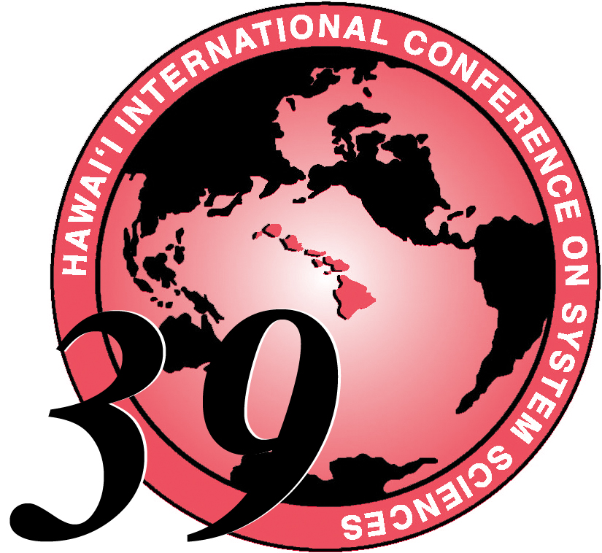
Fax to 808-956-5759 or email: hicss@hawaii.edu

TOTAL
PAYMENT

$_______

staff: ____
HICSS-39 GUEST REGISTRATION
Guest registration does not permit paper session attendance. Plenary or Distinguished
Lecture attendance does not require registration. Only Registered Guests
(including childen over age 6) may participate in daily lunches and/or the Luau.
The HICSS Luau includes a traditional Hawaiian feast, the Drums of Paradise revue featuring Hawaiian hula,
other dances of Polynesia, and a Fire Knife Dance. See http://www.hyatt.com/gallery/kauailuau/index.html
NOTE: You must purchase your Lunch tickets by 5pm the day before. No Luau tickets will be sold after Thursday, 5 pm and the Participant Luau Exchange ticket must also be exchanged for an Admittance ticket by this time, so that we can submit an accurate attendance guarantee.
CHOOSE ONE OR MORE OPTIONS:
❑ 1. (3) Lunches + Adult Luau $150 (Ages 13+)

❑ 2. (3) Lunches + Children’s Luau $100 (6-12 years old)
❑ 3. (3) Adult Lunches Only $85 (Ages 13+)  4. (3) Children’s Lunches Only $55 (Ages 6-12)
❑ 5. Selected Lunches (Ages 13+) @ $30 Each: Select Day(s): Thursday___ Friday ___ Saturday___
❑ 6. Selected Lunches (Ages 6-12) @ $20 Each: Select Day(s): Thursday___ Friday ___ Saturday___
Luau Only:
❑ 7. Luau Only: Adult (Ages 13+) $75

❑ 8. Luau Only: Children (Ages 6-12) $50

* There is no charge for children under age 6, but parents must assure that children of any age do not create noise or distraction during the dinner and show.
Guest Name(s) | Option Number  1 - 8 | Adult  Y/N | Child’s age | Booster Seat Needed? (Luau/Dinner) | Price
1.
2.
3.
4.
- CHECK # ________________ (Please make check payable to RCUH 002212/HICSS-39)  CASH

CREDIT CARD # __ __ __ __ __ __ __ __ __ __ __ __ __ __ __ __ Exp. Date __ /__

___ Visa or ___ Mastercard Card Holder's Name ________________________________

REGISTERED PARTICIPANT: _____________________________________ (please print)
E-Mail Address: _____________________________________________________

BRINGING CHILDREN? Camp Hyatt is an exciting year-round program for children. Supervised activities teach kids about Hawaiian plant life, animals, culture, and geography. Leimaking, seashell sculpture, Koi feeding, and tidepool explorations are among the arts and crafts, traditional games, and outdoor fun highlighting the camp’s half- and full-day sessions. Minimum age to attend camp is 3-1/2 years old and the child must be toilet trained. HICSS special rates are $65 for a Full-Day of activities with lunch. Please email hicss@hawaii.edu for additional information or see our web site. If you have further questions, you may email info@kauaipo.hyatt.com Tel: 808-742-1234 Fax: 808-742-1557

Outside babysitting services are available through Ohana Keiki Care - 808.639.8314

