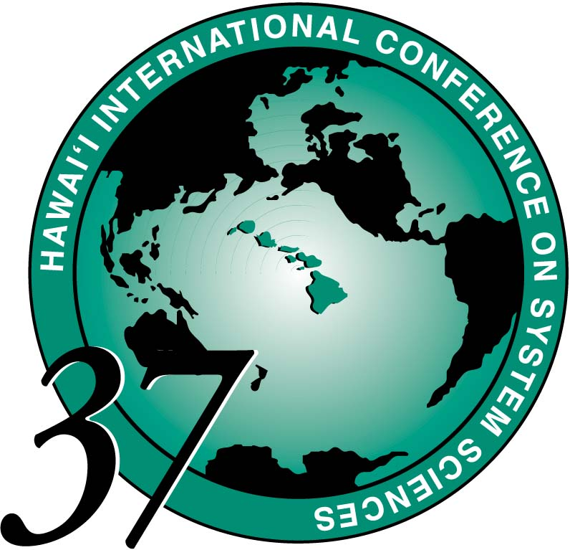

HICSS-37 CONFERENCE REGISTRATION

JANUARY 5-8, 2004

Hilton Waikoloa Village
on the Big Island of Hawaii

Last Name:

First Name:

□ Author: File Name Code of paper(s): □ General participant

□ Minitrack Chair: Minitrack code(s):

□ Tutorial Presenter - Name of Tutorial:

# of Years attending HICSS (including this year for HICSS-37):

FIRST NAME

Last Name

Corporate or
Academic Affiliation

State or Country
PLEASE PRINT
CLEARLY
FOR YOUR
NAMETAG

Employer: Department:

Street / P.O. Box:

City and / or Province:

State and Country & Zip Code

Home address or Professional address

Telephone: / Fax: /

E-Mail Address:

Website:

HICSS-37 Page 1 of 2
HICSS-37 CONFERENCE REGISTRATION FORM Page 2 of 2
YOUR NAME: (Please type or print clearly)

*********************************************** PAYMENT INFORMATION ************************************************
CANCELLATION POLICY: 100% refund until December 10, 2003; no refund after that day.

EARLY REGISTRATION Wednesday October 1 * $495
REGULAR REGISTRATION Thursday Oct 2 - Wednesday Dec 10* $545
LATE/On-Site REGISTRATION Thursday Dec 11* - Thursday Jan 8 $650
*Postmarked Date
□_  Visa or _□  Mastercard These are the only credit cards accepted.

Card Number Exp Date: /

month year
Name as it appears on credit card account:

Signature of Cardholder:

TUTORIALS ARE INCLUDED IN YOUR REGISTRATION FEE
****************************************************************************************************************************************

TUTORIAL DAY
MONDAY, JANUARY 5, 2004
See your Advance Program Announcement and the HICSS web site for tutorial abstracts and bio information about speakers.

Please mark your choice. You may choose one Morning and/or one Afternoon session.

Morning (9am - 12 noon)
□ Advances in Technology-Supported Learning
□ A Survey of Self-organizing Wireless Sensor Networks
□ Business Intelligence Foundation
□ Optimization Software Class Libraries
□ Persistent Conversation
□ Publishable Positivism

Afternoon (1pm - 4pm)
□ Civic Innovation and Democratic Design
□ Collaboration Engineering
□ Enterprise Information Technology Architecting
□ Fundamentals of Computer and Network Security
□ Multilingual Information Access
□ Simulation for Medical Training
□ Test Management and Organization

For more information call:
Sandra Laney, Conference Administrator, 808-956-3251 or email hicss@hawaii.edu
Make checks payable to HICSS / RCUH 001984 and mail to:
HICSS CONFERENCE OFFICE
2404 Maile Way A202
Honolulu, Hawaii 96822

PLEASE FAX BOTH PAGES TO 808-956-5759 OR EMAIL TO hicss@hawaii.edu
Please make your hotel reservations directly with the hotel as soon as possible. For a hotel reservation form visit
our web site http://www.hicss.hawaii.edu or go to http://www.hiltonwaikoloavillage.com
Please note that our special hotel rates are for registered attendees and their guests only.

