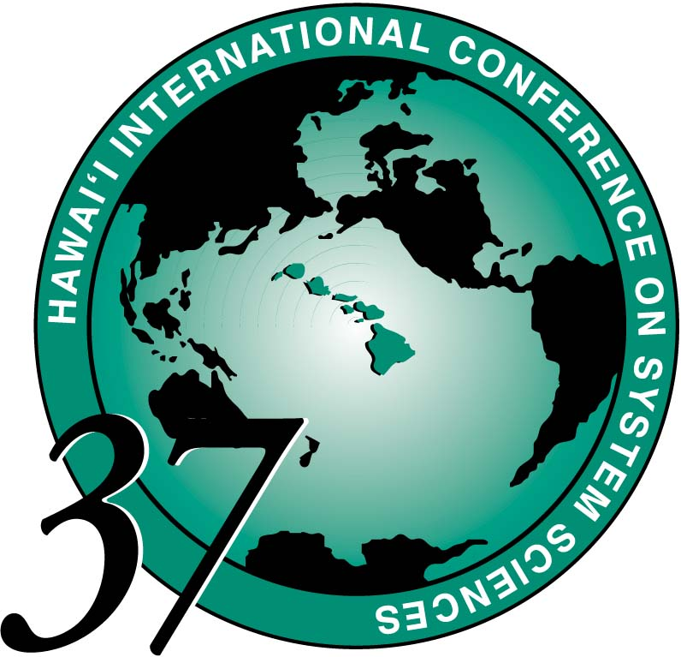
Guidelines For Tutorial Leaders

HICSS Conference Office: Tel: 808-956-3251 or Fax: 808-956-5759

The first day of a HICSS conference is devoted to tutorials, workshops, and advanced seminars. The objective of these sessions is to prepare for or re-enforce the paper sessions later in the conference, or to explore new topics. Although the tutorials and seminars generally include presentations, we encourage you to make the sessions as interactive as possible. Provided below are some suggestions to assure a successful session:

ABSENCES Each tutorial leader is expected to lead these Monday sessions in person. Those who find themselves unavoidably detained or unable to attend should immediately inform their co-presenter(s) so that adjustments in time, resources or structure can be made. If you are a sole presenter who is detained or unable to attend, contact the HICSS Conference Office at 808-956-3251 or hicss@hawaii.edu prior to 5pm, Friday, January 2. If after January 2 or on site, call the Hilton Waikoloa Village (808-886-1234), and ask for Sandy Laney or the HICSS Registration Desk.

AUDIO-VISUAL Please coordinate with your co-presenters to make a single request for your session's audio-visual needs. An AV Request form has been provided in your Appointment Packet, but it also may be downloaded from our web site http://www.hicss.hawaii.edu Fax this form to the HICSS office at 808-956-5759 by or email to hicss@hawaii.edu by November 1.

THE SESSION
• Begin the session on time - 9am for morning sessions, and 1pm for afternoon
sessions.
• Plan on taking a break about midway through the session. Coffee will be available from 10:15-10:45 in the morning and 2:15-2:45 in the afternoon.
• Please finish on time. There is only one hour for lunch after the morning session, and the organizational meetings begin soon after the afternoon session.

REGISTRATION You have received an Appointment Letter with information about your Conference Registration. Whether you have chosen to receive the honorarium or the complimentary registration, please register by the October 1, the Author Registration deadline. A special registration was emailed to you. If you need another one, please ask (hicss@hawaii.edu). Please make your hotel reservations prior to December 1.

TIME AND LOCATION Your Appointment Letter specifies whether you have a morning, afternoon, or full day session. We plan to notify you by December 1 of the exact room location for your session, and the number of people to expect. The room assignment is made primarily with consideration to the number of pre-registrations by December 1. We will work with you to assure that your needs are met, as these numbers may change up to the time of your session.

