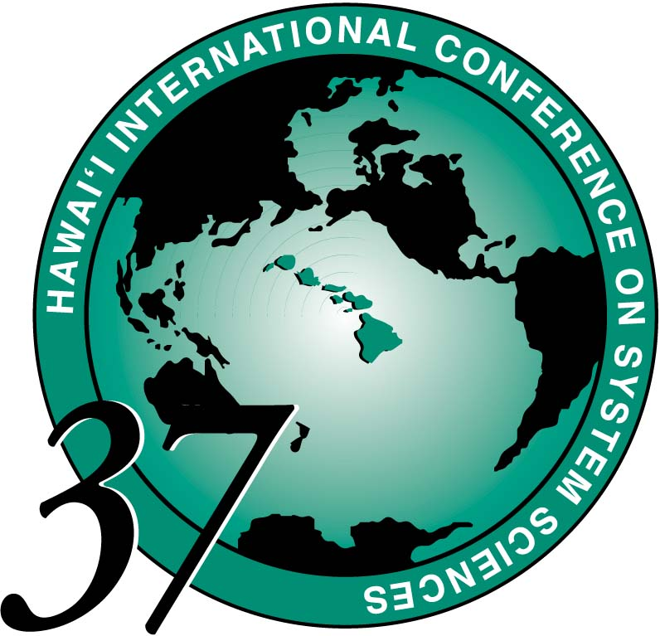
GUIDELINES FOR MINTRACK CHAIRS
(OR SESSION LEADERS)

An important objective of HICSS is to promote interaction and discussion among the participants. The success of the conference depends most heavily on the paper sessions. Therefore, it is important for each Author to summarize the paper in the time allotted and be prepared for discussion. It is YOUR responsibility to manage the session within this framework. Provided below are some guidelines to assure a successful session:

ABSENCES / Substitutes If you realize you cannot attend you should immediately let your TRACK CHAIR know of your absence. Appoint a substitute and provide clear presentation instructions and a copy of these guidelines. If you are a Session Leader, let your Minitrack Chair know of your planned absence. Substitutes should contact the Minitrack Chair as soon as possible after arrival, or inform the registration desk upon check-in for whom they are substituting.

AUDIO-VISUAL Please download an AV Request form from our web site http:// www.hicss.hawaii.edu and fax the completed form to the HICSS office at 808-956-5759 or email to hicss@hawaii.edu by Nov 1, 2003. If you have a late special request for your entire Minitrack, please see the registration desk to see if it is possible to accommodate your needs on site.
DISCUSSION TIME Discussion usually starts spontaneously as participants are ready and willing to ask questions, but the Session Leader must have one or two questions ready to get the discussion started. If discussion trails off before the end of the authors' allotted time, go on the next paper. There may be time at the end of the session for some discussion that compares and integrates the papers.
GETTING STARTED Please present the papers in the order shown in the program.
• Begin the session on time.
• Introduce the session, yourself, and the Authors.
• Provide an overview of how the session will be conducted. Include the order of the papers and an explanation of time limits and discussion periods.
SESSION TIME AND LOCATION Please do not change the time or location of your session. Should you have a problem or conflict, please inform the HICSS registration desk of your concern. We will work with you to assure that everyone's needs are accommodated as much as possible.
TIME and FORMAT Most sessions contain three (3) papers in a 90-minute time period. Encourage Authors to summarize their papers instead of reading them because the ensuing discussion is usually extremely valuable for everyone. The format may vary somewhat, but please promote discussion as much as possible.
• Allow 15 minutes for Authors to summarize the paper and 15 minutes for discussion.
• Give a 5-minute warning before the end of the allotted time and then cut them short, if necessary.
• Encourage people to continue discussions after the session ends. HICSS designs its conference so that break times and locations are conducive to continuing paper discussions.
BEST PAPER NOMINEES Awards are presented at the final evening event, 6pm Thursday. Session Leaders should mention at the beginning of a session if there are Best Paper nominees presenting. Please be sure to encourage the nominees to attend the award ceremony prior to the dinner on the last evening. (Winners present will receive a koa-framed award. Upon request, those not in attendance will have their unframed award mailed to them after the conference.)

MINITRACK CHAIR MEETINGS - MONDAY January 5
Please plan to attend. Room locations will be posted
4:30 - 5:15pm with Track Chairs
5:15 - 5:45pm with Authors
If any Author is unable to meet during this time, you must make every effort to contact the person or his substitute in advance of their session. The instructions each Author is given may affect their presentation and ultimately the success of the session. At this meeting, Minitrack Chairs or a designee will:
• Provide an overview of how the session will be conducted, including the order of the papers.
• Confirm the time allowed for each presenter. You may wish to have more presentation time, but be reminded that discussion is a very valuable feature of the session.
• Emphasize that papers are to be summarized -- not read -- and that the time schedule will be honored. A five-minute warning will be issued before the end of the allotted time.
• Verify the audio-visual needs for Authors.

