GUIDELINES FOR AUTHORS
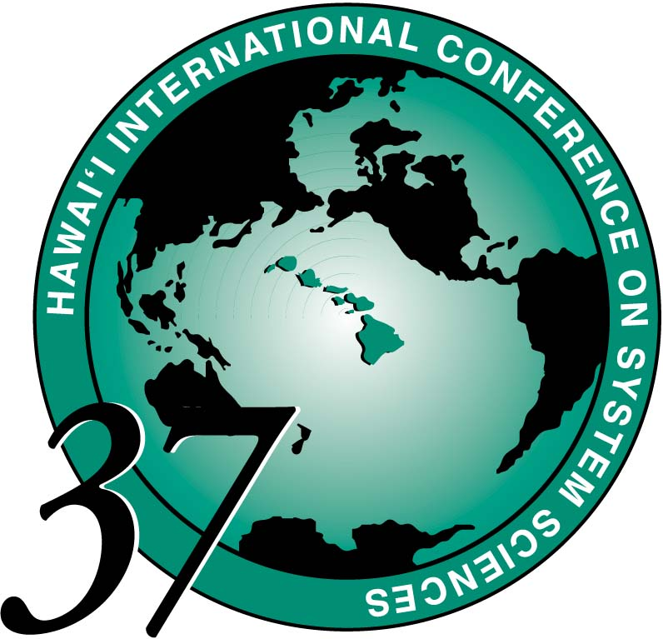

An important objective of HICSS is to promote interaction and discussion among the participants. The success of the conference depends heavily on the paper sessions. Therefore, it is important that each Author only give a summary of their paper in the allotted time, and then be prepared for discussion.

The following are some requirements to assure a successful presentation:

ABSENCES / Substitutes If an emergency prevents you from attending the conference at the last minute, please appoint a substitute. You should immediately inform the Session Leader / Minitrack Chair of any substitution. The substitute presenter should be given clear presentation instructions and a copy of these guidelines, and should be encouraged to contact the Session Leader upon check-in. Appoint someone who is familiar enough with the paper to summarize it and to lead a discussion on it. Do not appoint someone merely to "read the paper" -- informed discussion is basic to a HICSS conference.

AUDIO-VISUAL Please download an AV Request form from our web site http:// www.hicss.hawaii.edu
Fax the completed form to the HICSS office at 808-956-5759 or email to hicss@hawaii.edu by Nov 1, 2003.

Authors’ meeting - Monday January 5 5:15 pm to 5:45 pm
Please plan to attend. Room locations will be posted. If it is impossible for you to arrive in time for this meeting, appoint a designee, or contact your Session Leader as soon as possible re: your substitute presenter. Arrangements must be made to convey important information by the time of your presentation. Minitrack Chairs who have been notified of an absence also will try to contact the substitute in advance of the session. The instructions each presenter is given may affect their presentation and, ultimately, the success of the session.
At this meeting, Minitrack Chairs will:
• Provide an overview of how the session will be conducted, including the order of the papers.
• Confirm the time allowed for each presenter. You may wish to have more presentation time, but be reminded that discussion is a very valuable feature of the session.
• Emphasize that papers are to be summarized -- not read -- and that the time schedule will be honored. A five-minute warning will be issued before the end of the allotted time.
• Verify the audio-visual needs for Authors.

Summarize, don’t Read
- Convey the main concepts, key results, implications, and future work. This suggests the use of 4 or 5 transparencies with several bullet points on each.
- Use only 15 minutes to summarize the paper and allow 15 minutes for discussion. The discussion that follows will prove valuable to you and your research.
- Please do not use time allocated to other presenters by going over your time. Respect your colleagues by honoring the 5-minute warning given before the end of your allotted time.

AFTER THE Conference...
HICSS has a high ratio of conference papers that become journal articles. Plan to submit your paper to a journal, making revisions based on discussion during your session. Check with your Minitrack Chair for suggestions and/or to see if a special issue of a journal is planned.

