Affiliated University Sponsors of HICSS-37
UNIVERSITY OF ARIZONA The University of Arizona is embarking on celebrating 30 years of its contribution to the MIS fields in 2004, with many activities planned all through the year including:
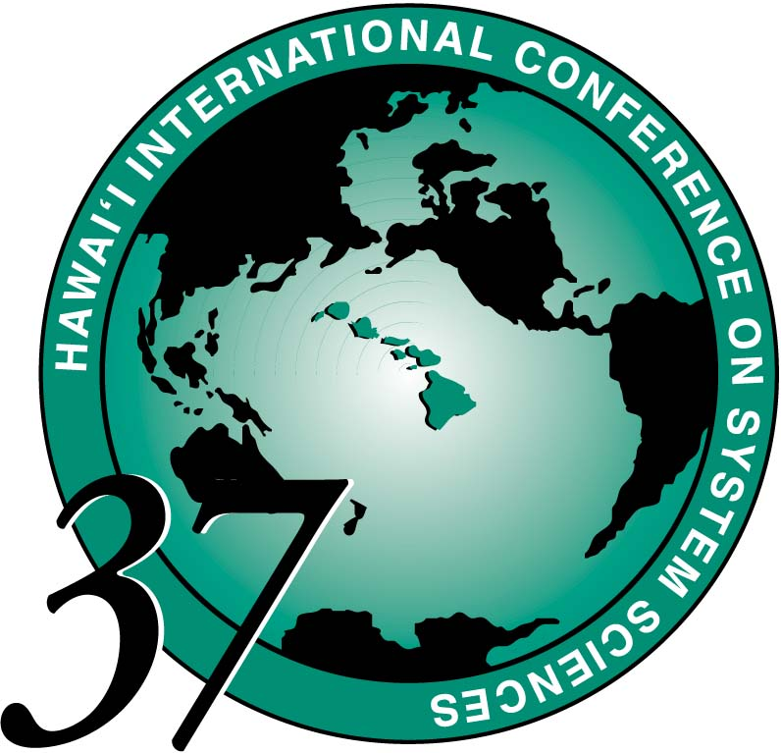
- Focused symposia on process outsourcing, law, life science, global IT management, etc.,
- Alumni golf-outings for generating scholarship funds,
- Several major conferences (ACM SIGMIS on April 22-24, Joint Conference on Digital Libraries on June 6-11, Symposium on Intelligence and Security Informatics on June 10-11), and
- A gala one-week long IT-related conference event November 1-6.
Ultimately, our goal is to make this anniversary year one in which we, as an MIS academic community, not only celebrate our contributions to IS research and practice, but also recognize our responsibilities in judiciously guiding the development, research, and practice of information technology in the decades to come.

SINGAPORE MANAGEMENT UNIVERSITY The Singapore Management University (SMU) was incorporated in January 2000. While it is a publicly funded institution, it is chartered in a unique way to provide the flexibility and operating characteristics of an American-style private university. SMU’s mission is to generate leading-edge business and business-technology research with global impact, and to produce creative and entrepreneurial leaders for the knowledge-based economy.
The School of Information Systems (SIS) was launched in 2003 to establish strong research and education capabilities in the area of business-focused information technology, systems and applications. SIS is in the heart of Asia, well-connected to the local, regional and global community of IT users, providers and researchers.
The Carnegie Mellon Collaboration - In January 2003, SMU & Carnegie Mellon University signed a four-year collaborative agreement to support the establishment of SIS. Carnegie Mellon faculty and staff are actively participating in SIS faculty selection, mentoring and development, and in the design of the SIS undergraduate curriculum, research center, and post-graduate and professional programs. Through this agreement, SIS and Carnegie Mellon are actively exploring mechanisms for jointly delivering masters and professional programs, and for jointly executing research programs and projects.
Research and Education Strategy - SIS is recruiting faculty members who are pursuing leading edge interdisciplinary research work in one or more of four main areas:
- e-business enabling technologies and applications
- information security and trust
- architecture and software engineering
- information systems management
SIS research and educational projects will demonstrate innovative IT applications and economic value propositions in the following industry sectors: financial services, logistics and supply chain services, health and medical services, e-government and public sector services and manufacturing. We are especially interested in faculty members who are highly motivated to collaborate with domain experts in these sectors or who already have domain experience in at least one of these sectors.
A major research center focusing on cybersecurity and e-business will be launched in collaboration with Carnegie Mellon during 2004. This research center will provide opportunities to pursue major research initiatives in partnership with the private sector and governments.
A distinctive feature of the Bsc (Information Systems Management) program is the dual emphasis on the technical skills for the design and deployment of business information systems and on the business skills for analyzing value, costs and risks of solution alternatives. The program also has a strong emphasis on IT project management and will provide students with numerous in-depth experiences with the end-to-end process of defining, designing, and deploying solutions. The program also gives students the flexibility of combining information technology with an industry sector concentration and a business function concentration, giving SIS graduates a distinct advantage in the commercial world. Candidates must be capable of designing and delivering one of the following undergraduate courses: Object oriented systems, Data management, Networking, Software engineering, Enterprise systems and integration, Security, Architectural analysis, or related electives.
Applications for tenure-track and practice track are invited at all levels. For more information on faculty opportunities at SMU, or to apply for a position, please contact:

Steven Miller Email: siscv@smu.edu.sg
Dean, School of Information Systems DID: (65) 6822 0901
c/o Office of Faculty Administration FAX: (65) 6822 0919
Singapore Management University Please visit the SMU website at www.smu.edu.sg and the SIS
469 Bukit Timah Road website at www.sis.smu.edu.sg
Singapore 259756

