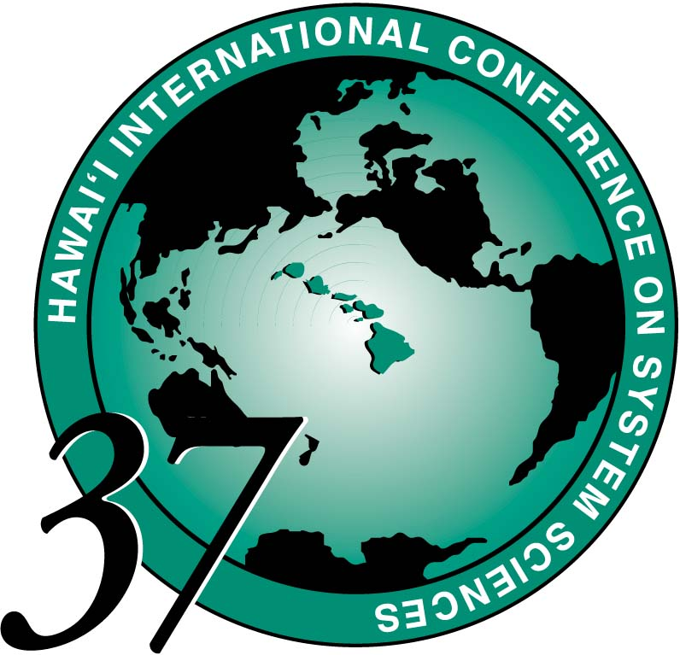
This Guest Registration does not permit paper session attendance.
Plenary Lecture, Distinguished Lecture, and receptions are open to everyone.

Fax to 808-956-5759 or email: hicss@hawaii.edu
HICSS-37 GUEST REGISTRATION

Choose one or more

1. (3) LUNCHES - $85

2. (3) Lunches + Adult Luau - $140

3. Selected Lunches @ $30 Each: Select Day(s) - Tues_____ Wed_____ Thurs_____

4. Luau Only: Adult - $65 (Age 13 +)
€ Children’s Luau: $20 (5-12 years old)
- Lunches Adult prices only.
- Luau Price includes professional hula show entertainment by the renowned Tihati Productions. (http://www.tihati.com ) The Children’s Luau price must be paid for any child not kept in a stroller or in arms. Parents are expected to assure that their children of any age do not create distraction by noise or behavior.

Guest Name(s) | Option Number | Adult  Y/N | Child’s age | Booster Seat (Luau/Dinner) | Price
1.

2.

3.

- CASH
- CHECK # _________________ (Please make check payable to RCUH/HICSS-37.)

CREDIT CARD # __ __ __ __ __ __ __ __ __ __ __ __ __ __ __ __

___ Visa or ___ Mastercard Exp. Date ___/___/___

TOTAL
PAYMENT

$_______

staff: ____
Card Holder's Name _____________________________________________________

REGISTERED PARTICIPANT: _____________________________________
Please print

E-Mail Address: _______________________________________________________

BRINGING CHILDREN?
Camp Menehune, the Hilton's childcare program, is a fun and activity-filled program on the hotel grounds for ages 5-12. Special rates for HICSS families: $50/Full-Day or $35/Half-Day, both with lunch. HICSS Night Camp is planned for Thursday, 6pm-9pm, including dinner and special children’s hula show for $35. In-room childcare references are provided for young children throughout the week. 24-hour cancellation notice for camp services is required. More details can be found on http://www.hicss.hawaii.edu/HICSS37/apahome37.html
To pre-register for Camp Menehune, please call 1-808-886-1234, ext. 1202 or visit http://www.hiltonwaikoloavillage.com/camp/

* menehune means "little person" or an ancient elf in Hawaiian cultural stories.

