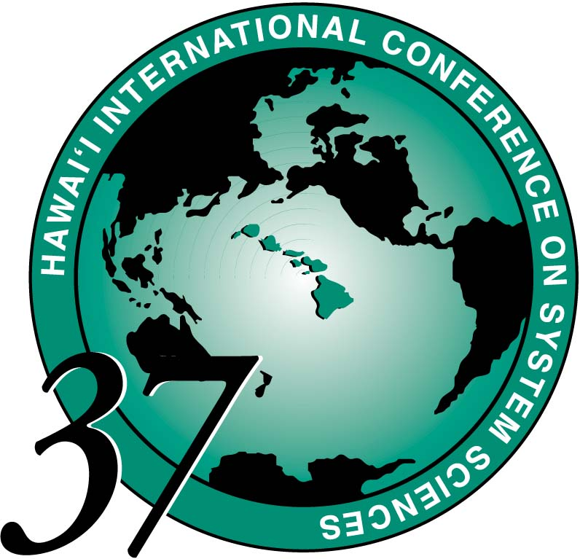
HICSS-37 REQUEST FOR AUDIO-VISUAL EQUIPMENT
PLEASE FAX THIS FORM TO 808-956-5759 BY OCTOBER 1.

We require a separate request for each session, unless it is specifically noted
as for an entire Minitrack. Facilities for making transparencies will be available
at the hotel's Business Center.

YOUR CONFERENCE ROLE:
 AUTHOR- PAPER CODE: ______________

❒ MINITRACK LEADER: _____________________________________________
Title of Minitrack

 TUTORIAL/WORKSHOP LEADER: ____________________________________ Title of Session

 PLENARY SPEAKER OR DISTINGUISHED LECTURER

YOUR NAME: 1. _______________________________________________________

Co-Presenters:
2. _________________________________ 3. ________________________________

4. _________________________________ 5. ________________________________

Contact Address: ________________________________________________________

________________________________________________________

Telephone: _____/ _____________________ E-mail: __________________________

Please select:
 Data Projector / Beamer  Overhead Projector
Presenter is responsible for bringing own computer. ___ 2nd Overhead Projector

___ Flip Chart

___ VHS (1/2") video cassette player

___ Kodak35 mm slide projector. Presenter is responsible for providing carousel.

 If you have other needs, please contact the HICSS Conference Office hicss@hawaii.edu by November 1, 2003.

